SEXUALITY EXPLAINED
ALONG WITH HIV/AIDS FACTS

The History of HIV and AIDS

Background

It is thought by medical people, from reviewing records earlier, that HIV and AIDS existed prior to the 1980s but was not recognised. It was first discovered in early 1980s (1981) in an airline flight attendant (male) who became very ill and was placed in hospital in the Americas. In searching for possible causes, a rare form of pneumonia was discovered along with severe deficiency in the immune system, which they later called HIV. In trying to identify this virus and possible cause of infection, some significant factors arose that led researchers to the conclusion that this viral infection was specifically related to sexual behaviour. This flight attendant was homosexual and had engaged in casual sex in different localities. In testing his sexual partners, some of these were found to also carry the virus, later called HIV. There were many unknowns then about this virus, and much is still unknown today. We do know, at this writing, that there are different strains of the HIV virus (strains A, B, C, D, etc.). The ‘A’ and ‘C’ strain are the most prevalent in Africa with the ‘C’ strain most common in South Africa. The ’B’ strain is most common in the USA and the West. Unfortunately, most of the medical research and drugs available to help AIDS sufferers concern the ‘B’ strain. Much more research needs to be concentrated on the more prevalent strains of ‘A’ ‘C’ and ‘D’ found in Africa and the developing nations where AIDS hits hardest. The main factor established is that HIV and subsequent AIDS is primarily a sexually transmitted disease (S.T.D.) and the most serious of the more than fifty STDs that now plague our world. In the 1950s, there were approximately five known STDs prevalent, but now so many more have been discovered, many having deadly consequences. (Note: See Chapter 7 on STDs.)
FACT 78
Mistaken Beliefs about Origin of HIV and AIDS
FACT 01

H uman I mmuno-deficiency V irus

There are many myths floating around, some of which are the following:
- HIV came from monkeys.
- HIV accidentally mutated in the testing of immunisations in the USA, with something going wrong and HIV resulting.
- HIV was developed in the USA specifically to wipe out underdeveloped nations and particularly Africa.
FACT 32
- HIV is another germ warfare developed by superpower nations.
- AIDS is the American Idea to Discourage Sex. Others think it is the
African Idea to Discourage Sex.

Whatever the origin (and we generally hold the above ideas to be myth), we must rather be concerned about where HIV and AIDS is going, rather than from where it came. We know HIV and AIDS is here! It is catastrophic and wiping out mainly the productive members of society (youth and young adults) in unprecedented numbers.

HIV (Human Immuno-Deficiency Virus)
FACT 02

Can we see HIV? No! It is so small that as many as 230 million HIV viruses can rest on a full stop at the end of a sentence of normal type. It is smaller than sand or a human body cell.
FACT 03

A Person with HIV
FACT 07
Approximately 90% of people who have the virus living and reproducing in their body do not even know it themselves. This is because an HIV-infected person at first looks and feels healthy and normal. This is how HIV cheats us! You cannot feel it entering your body; most do not even know it is there destroying their body. Many people with HIV killing their body can look and feel well for five years or LONGER. In Africa many people take as long as three to five years before they begin to show symptoms of illness from the HIV virus in their body. However, in some people it can be a shorter or longer time before they begin to show symptoms of sickness. Some have been free of symptoms for longer than 10 years, although this is not an average in Africa.
FACT 05
FACT 04
STAT 35
STAT 36

The sad thing about HIV and AIDS is that people spread this virus mainly to people they care about and love, e.g. husbands and wives infect one another; girlfriends and boyfriends infect one another; mothers infect babies, etc. HIV infection causes the disease of AIDS and is a killer.
FACT 08
FACT 18

How Does HIV Infect, and What Does It Do in a Body?
Every person is born with a natural defense force in his/her body called the immune system. The body’s defense force is made up of soldier cells (T-cells) that fight against disease when it enters the body and chase sickness from the body.
FACT 24

HIV and AIDS Not-Spread

- Not spread by shaking hands
FACT 19
- Not spread by sharing eating utensils or living in the same house
- Not spread by casual hugging, touching
- Not spread by sharing a toilet or wash basin
- Not spread by casual kissing on the lips
- Not spread by sneezing, coughing, or in the air
- Not spread by recreation or children playing with an infected child
- Not spread by mosquitoes, insects or other animals

This is why we do not have to be afraid of HIV and AIDS. It is neither easily contracted nor “caught” like many other diseases. It is behaviour that puts a person at risk for this disease. You must DO something to contract HIV that gives you AIDS.
FACT 25

How Does HIV Infect a Person?
- HIV enters through direct blood on blood contact. This can be by sticking one’s skin with an infected needle, tool, etc. Some ways where this can happen are through the following means:
FACT 11

- Sharing a needle for ear piercing or tattooing.
FACT 13
- Sharing a needle for drug injection, immunizations with re-used needles.
- Reusing instruments for circumcision that have not been boiled for 30 minutes after every use or before use.
FACT 20
- Unsterilised instruments used in dental work.
- Medical workers through a needle prick from someone who is HIV infected.
- Handling infected blood with an open sore.
- Deep mouth kissing (called French kissing) with an infected person
if you have a sore in your mouth. (This is rare but can happen.
FACT 21
Therefore deep-mouth, casual kissing is neither a wise nor safe
practice.)
- In the birthing process from the infected blood of a mother to the new
baby.
FACT 26
Contracting HIV through ways other than sex is the lesser way that the virus is passed from one person to another. Estimates say that approximately 5% only of HIV infection causing AIDS is now spread through ways other than sex.

- HIV must enter through direct body fluid contact. This is the most frequent way HIV infects people and it accounts for an estimated 95% of the spread of HIV and AIDS. The main way this happens is through sexual contact through the private part body fluids. If a person is HIV positive, he/she can spread the virus immediately. He/she does NOT have to be sick with symptoms or be in full-blown AIDS. Again, this is where HIV cheats us because a person can have sex thinking the person looks healthy, therefore they are not infected. This is how HIV is spreading so rapidly. Here are some facts about the sexual spread of HIV:
FACT 11
- mainly through full private-part sex when body fluids are mixed;
- sexual contact on the outside of the body CAN put one in danger
if there is a possibility of body fluid getting inside the body, e.g.
through a sore or cut, just outside the private parts where the body
FACT 17
fluids can still mix and a small amount go inside the body;
- having sex with ANYONE (either male or female) who might be
infected (whether thin or fat) puts a person at risk for HIV infection.
It is estimated that 95% of the spread of the HIV virus that leads to AIDS is from sexual contact. Therefore, it is totally accurate to realise that if the sexual behaviour of individuals can be changed to keep sex in marriage only, one man with one woman for life, then we could virtually wipe out AIDS.

- Infected mother to baby. HIV infected mothers can pass the HIV virus on to their baby through breastfeeding. The very best way a mother can feed her baby is still through breastfeeding. In Africa particularly, feeding babies with a milk formula in a bottle can be very dangerous if the water if not adequately boiled first, and if the milk powder does not contain sufficient nutrients for a healthy baby. Therefore, mothers are encouraged to breastfeed their baby. However, mothers who suspect they might have been exposed to the HIV virus should get tested before they begin to breastfeed their newborn baby.
FACT 28
FACT 27
The incidence of HIV-infected mothers giving birth to HIV-positive babies is approximately 30 to 50%. There are some treatments (AZT and related cocktail mixtures) that can reduce the possibility of an HIV-infected mother’s baby also being infected. These treatments must be given during the pregnancy and for the most part, are far too expensive and unavailable to mothers in many parts of Africa. Therefore, women are urged to be certain they are tested for HIV before they become pregnant.
FACT 30
FACT 28
Situations Where HIV Is Sexually Spread

- Heterosexually before marriage from a man to a woman, or a woman to a man engaging in sex, rationalizing the following:
SEXU 37
- My partner/lover is healthy, therefore, I am safe. That is not necessarily true. All persons who are HIV infected look healthy at first.
SEXU 04
- It can’t hurt because we love each other. Many think ‘love’ means having sex. That is not true. Animals have sex and they definitely do not love each other!!
It is important to note that many people who engage in sex before marriage do it with one or more persons. That means it is very likely that the person having sex with the person they say they love before marriage, has done this before and has had sex with more than one other person. Remember, when a person sleeps with another, he/she not only sleeps with that person, he/she is also sleeping with every other person their partner/lover has ever had sex with. It is just the same in terms of HIV and AIDS as all the sexual partners of those involved crawling into the same bed together at one time!

After marriage, individuals being unfaithful to their spouse not realising the fact that they could well be killing themselves, their spouse, their unborn children, and/or their breastfeeding children. Many a married partner has given in to sexual temptation by having a girlfriend/boyfriend (other than their married spouse) for sex, and has brought the AIDS disease home. A number of unofficial surveys were conducted in the South Africa region by asking the following question of married males and females, “Have you cheated on your spouse since you have been married?” The women answered with a high percentage saying they had never cheated on their husbands. However, well over two-thirds of the married men admitted that they did cheat on their wives. Many married men surveyed felt that because they were men, they were entitled to cheat and that having girlfriends made them more masculine. Unfaithful sex outside of marriage kills other family members! This is very common around the world and ever so tragic. Women are innocently and unknowingly contracting HIV and STDs through the unfaithfulness of their husbands. Thus, the incidence of new HIV infection in women is increasing at a rate of approximately 33.3% faster than new HIV infection in men.
SEXU 03
SEXU 80
SEXU 23
STAT 33
- Homosexually having sex with a person of the same sex, either man with a man or woman with a woman. This used to be totally foreign in African culture. It is more common in Western cultures. However, in some African countries such as South Africa, same-sex relationships are now protected by the constitution. Homosexuality is promoted subtly through TV, and same sex is now being experimented with by young people and even openly declared by many in Africa in the 90s. It is totally a myth that AIDS is ONLY a homosexual disease. Often homosexuals engage in sex through the anus (the rectum where solid waste is discharged from the body). Anal sex carries the highest risk of HIV and AIDS infection because the thin rectal lining was never designed for sexual activity and is easily injured during this unnatural sex. In Africa particularly, heterosexual sex (male/female sex) is by far the greater spreader of HIV and AIDS. However, it is also a myth to think that same sex (homosexual sex) is safe from HIV and AIDS or that it doesn’t happen in Africa; it does. Homosexual sex is dangerous and an abomination to God. (Read Romans, Chapter 1.) Homosexual sex between males is often expressed orally on the private parts with the mouth. (See Oral Sex Spread of HIV and AIDS.)
SEXU 38
SEXU 37
- Sex with children is a myth that is being told (particularly in parts of Africa, India
Eastern Asia, etc.), that boasts to cure HIV infection and AIDS if you have sex with a virgin child. This is a tragic lie. If an adult (who may be HIV positive, knowingly or not) has sex with a child, this causes the HIV infection to be passed on to the child and also leaves the child with permanent psychological scars. (Note: See Chapter 12 on Sexual Abuse.)
SEXU 39
SEXU 18
- Oral sex is having sex using the mouth on the private parts for sexual arousal. Many mistakenly think that this is safe in so far as HIV infection is concerned. This is not true. While there may be less chance of the HIV virus entering the body through the mouth than in the private parts, oral sex can and does spread sexually transmitted diseases and HIV infection through small tears or openings in the delicate skin in the mouth (called mucosal skin). Often an oral sex partner finds sexually transmitted sores show up on the mouth and/or face because of having sex orally with an infected partner.
SEXU 40
- Sex with animals is a deviant form of sexual expression that is sinful and harmful to the mind and to the body. While animals are not carriers of the human form of the HIV virus, sexual contact with animals can lead to many other kinds of diseases that make the body weak and more susceptible to the HIV virus. This form of sex is against the Bible and is an abomination to God.
SEXU 41
SEXU 42
- Female cleansing after husband’s death is another way HIV and AIDS is spread, particularly in areas where this is still practiced. Mistakenly, this is often thought to be a purifying rite. However, it is another cause of the spread of sexually transmitted diseases including AIDS, where one of the persons can be unknowingly infected. Thus, this sexual practice is another way that AIDS is sexually spread. This neither cleanses nor serves as a moral, useful way of helping the bereaved female member of a family, or the extended family.

- Deep Mouth Kissing generates a great deal of differing opinions as to whether or not the HIV virus can be passed this way. If we are going to be totally honest about the possible spread of HIV, we must consider the matter of deep kissing. Unfortunately, it is extremely difficult to track the ‘source’ of the HIV infection in a person other than to try to track possible sources of infection. We do know that the HIV virus is extremely small, and is spread by direct blood contact. When considering the possibility of the blood of an infected person passing into the body of another person through deep mouth kissing (tongue in the mouth), we need to know the following:

Quote from Col. Robert Redfield, J. D., Virus Disease Center, Walter Reid Army Medical Research Centre published by Regnery Gateway, Inc.

“To be intellectually honest with our students, we must tell them the
truth; therefore, we should tell them that at this time (which was 1990)
there has been no known incident of the HIV virus being transmitted
by kissing. However, there is NO PROOF that it is not happening,
nor is there a guarantee that it won’t happen in the future. There is
about a 4% transmission rate that is unaccountable. Shouldn’t we
remind them that blood is contained in saliva and the mouth is a soft
mucous membrane?”

Quote: January 13, 1989 Journal of American Medical Association

“During kissing…if the blood of one partner is infected, human
immuno-deficiency virus can pass into the bloodstream of the
other partner.”

Quote: 1989 American Medical Association on “Passionate Kissing and Micro-Lesions of the Oral Mucosa,” forty-five heterosexual couples were asked to collect saliva immediately before and after the following:

- Brushing teeth
- Eating the main meal of the day
- Passionate kissing

The amount of blood in saliva after three activities was rather surprising:
- Before brushing teeth - 44 of 90 (49%) had blood in saliva
- After brushing teeth - 71 of 90 (80%) had blood in saliva

- Before eating main meal - 41 of 90 (45%) had blood in saliva
- After eating main meal - 50 of 90 (55%) had blood in saliva

- Before kissing - 35 of 45 (78%) had blood in saliva
- After kissing - 41 of 45 (91%) had blood in saliva

Quote from researchers: “In our opinion, the result of this study indicates that passionate kissing cannot be considered protective (safe) sex for the transmission of the HIV virus.”

Deep mouth kissing (passionate kissing) outside of marriage is unsafe for two reasons:

- AROUSAL – Passionate kissing most often will lead to other
sexual acts which definitely put one at risk. Those who engage
in passionate kissing before marriage will progress on to other
sexual acts, obviously putting themselves at risk for HIV infection. It doesn’t stop at kissing!

- TRANSMISSION OF HIV – If there is even a speck of blood in the mouth (representing possibly several millions of HIV viruses in that blood) and there is a small opening for the virus to penetrate, it is possible that a person can become infected in this way. Therefore, young people need to be informed and warned that passionate kissing is not to be fooled with. Casual deep mouth kissing IS DANGEROUS!

Understanding the Male Reproductive System
(Glossary of Terms & Side View)

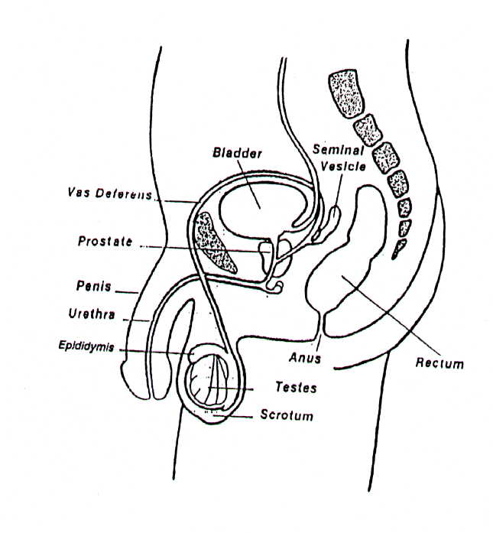
Penis The primary male sex organ, used for elimination of urine (liquid body waste) and for sexual intercourse. During sexual arousal, the penis expands or erects to approximately 5 to 7 inches and about
1 to 1 ½ inches in diameter. The size of the penis has nothing to do with manhood or a man’s ability to be sexually fulfilled or produce a child.

Ejaculation The release of semen (fluid coming from the opening in the penis) from the male private part, the penis, during sexual intercourse
or sexual arousal. Usually a male will ejaculate approximately
1 teaspoon of fluid during sexual intercourse.

Semen Also known as seminal fluid. Contains sperm and fluids which come out of the male penis during sexual orgasm. It is the sperm

in the semen which fertilises the female egg and makes a baby. Approximately 150 million to 600 million sperm are contained in the semen.

Orgasm The height or climax of sexual pleasure in a man where his private part ejects semen from the penis. The height or climax of sexual pleasure in a woman where her private parts swell with moisture and pleasant sensations are felt.

Sperm Male sex cells (comparable to the egg or ovum in the female) which fertilise the female egg and produce a baby. Sperm make up about 2% of the male fluid (semen) that is ejaculated during sexual intercourse. The male sperm are so small that several million can sit on the size of a pinhead.

Sexual Intercourse The joining of the male and female private parts, originating as God’s idea and taught in the Bible as for the purpose of intimacy in marriage and for the procreation of children within the family unit.

Prostate Gland A gland at the base of the bladder that produces most of the male seminal fluid.

Scrotum The pouch that contains the testicles and controls the temperature for the male sperm production.

Testicles Located in the scrotum where the male hormones and the sperm cells are produced in the male.

Urethra The tube running through the penis by which urine and sperm leave the male’s body. A small valve at the entrance to the bladder prevents urine from entering the urethra during male ejaculation.

Puberty The age of development in a boy where physical and reproductive development occur. It is at this age where physically a boy can father a child. Manhood, readiness for marital responsibility and fatherhood, needs to be nurtured by character building and godly instruction during these “teen” years until the boy has matured into full manhood. Only then is he ready to take up the responsibility of marriage and fatherhood, usually much later than the onset of puberty.
Someone once said, “One is born male, but it is character development that makes a boy a man.” Physical characteristics do not determine whether a male has truly grown up to be a man in the Biblical sense. One can have the physical characteristics of a man yet still act like a child in character. That man has never reached his full potential to be the man God created him to be. Only his physical parts are grown up while the rest of him is still acting as a child.
SEXU 43
1 Corinthians 13:11 “…When I was a child, I spoke as a child, I understood as a
REFR 08
child, I thought as a child; but when I became a man, I put away childish things.”
SEXU 44
Masculinity and being “macho” in the modern sense of the word are not to be confused. They are very different. A real man is a male person who has grown up to be caring, considerate, compassionate and conducts his life with wisdom, maturity and responsibility. That means he has truly put away childish things and is a man in every sense of the word. A male who has never developed into full manhood is characterised by “childishness” which is shown in his lifestyle by selfishness, “me” centered behaviour using other people for self-gratification, and irresponsibility, just to name a few. The modern philosophy regarding sex of “if it feels good do it” and “being physically able to do sex,” does not fit into God’s Word regarding true manhood. Many young men wrongly understand their manhood to mean their sexual familiarity with the opposite sex, size of private parts, or their ability to father a child. Nothing could be further from the truth. Jesus Christ, God’s Son, was the embodiment of manhood, yet He never exploited women, never had sex, and never fathered a child. Jesus epitomises how God created manhood to be.
SEXU 02
A Young Man’s Body Explained
Boys are created with sexuality at birth, as are girls. Sexuality in itself is NOT evil since God created it in all human beings. As boys grow up, they need to be taught about the gift of their body and how to properly develop inner character as well as a healthy body. Sometimes young boys will be curious about physical parts of the body, especially private parts. It is during these years that boys need godly guidance and instruction, firstly from their parents, then from elders in the extended family, and the local church elders. This time of development is to positively channel the boy’s energies into creative character building, e.g. taking family responsibility, doing chores, going to school and the education process, constructive play with peers, sports, etc. It is perfectly healthy and normal for a young man, prior to marriage years, to not have sex. Young unmarried men of any age should not have sex if they want to follow God’s commandments. They will still grow up to be properly developed in their private parts and they will have healthy, fulfilled sexual lives if they wait for sex until they are married.
SEXU 45
SEXU 01

Nocturnal Emissions or “Wet Dreams”

During this time of puberty, most boys experience the release of semen during a nighttime dream. This can be embarrassing to young boys growing up and they need to be taught that it is a normal experience for most boys.
SEXU 46

Masturbation

Most boys (and often girls too, although not as commonly as with boys), will feel varying sexual feelings begin in their body at puberty. It is at this age where boys, in particular, are often tempted to masturbate. Masturbation is self-stimulation of one’s own private parts to experience a sexual feeling. God’s Word does not specifically speak to the issue of masturbation itself. However, it is the belief of the authors of this book that
in principle, God’s Word deals with masturbation and other forms of sexual stimulation outside of marriage in the following way:

Philippians 4:8 “…whatever things are true, whatever things are noble, whatever things are just, whatever things are pure, whatever thing sare lovely, whatever things are of good report, if there is any virtue and if there is anything praiseworthy – think on these things.”
REFR 08

Most people who yield to the temptation of masturbation tell the same story--that this form of sexual gratification can lead to the following: impure sexual thoughts, masturbation becoming a habit, masturbation as a cheap substitute for sexual expression within marriage at the appropriate time, feelings of guilt, feelings of shame, etc. We believe that masturbation is not God’s plan for sexual expression. Rather, sexual feelings prior to marriage or in marital situations where sexual intimacy is not possible (absence,
during birthing, illness, etc.), or after the death of a spouse can be channeled to productive non-sexual activity. For example: When a young person feels sexual feelings in his/her private parts, rather than give in to the temptation to masturbate, rather immediately take up another activity such as sports, hard work, etc. This not only alleviates the immediate need for sexual gratification, but teaches self-control and character building. It is not the temptation to masturbate that can lead to destructive thoughts and deeds, but how that sexual energy is channelled to non-sexual forms of activity until one is married.

Puberty marks the beginning of physical maturity and functionality. The boy’s brain begins to send signals to his pituitary gland, which signals many other glands that begin to release hormones into the bloodstream and then into the sex glands.

The most important male hormone, testosterone, is released and begins the boy’s journey to sexual maturity. At this age (usually about age 12 to 13 years, but can differ from boy to boy) you will notice some physical changes begin to appear: the legs and arms grow rapidly and have more muscle; hair begins to appear around the private parts and on other parts of the body including the face; the private parts begin to enlarge; skin changes often appear as the oil glands become more active, sometimes causing acne (pimples on the face); the voice begins to deepen. etc.

Understanding the Female Body and Reproductive System
(front view)

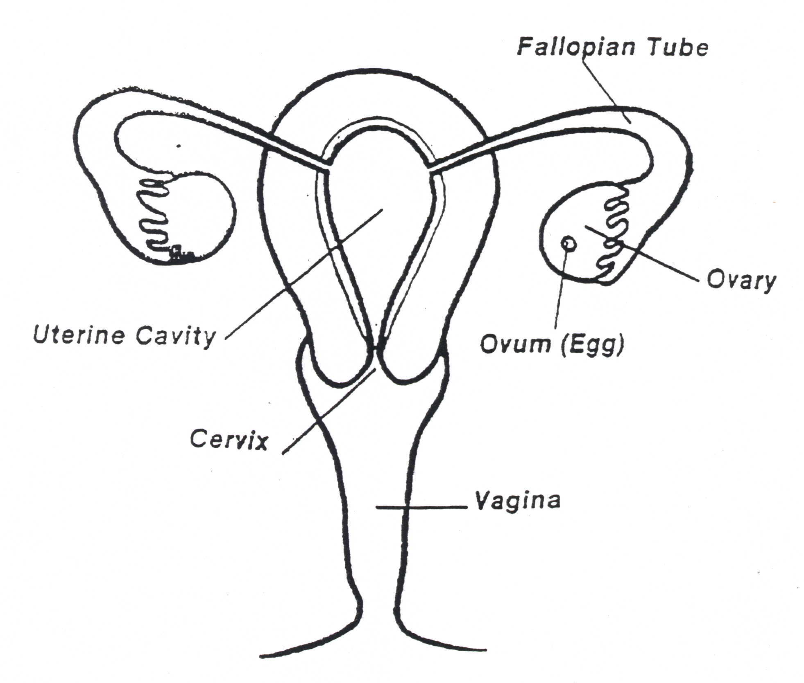

(side view)
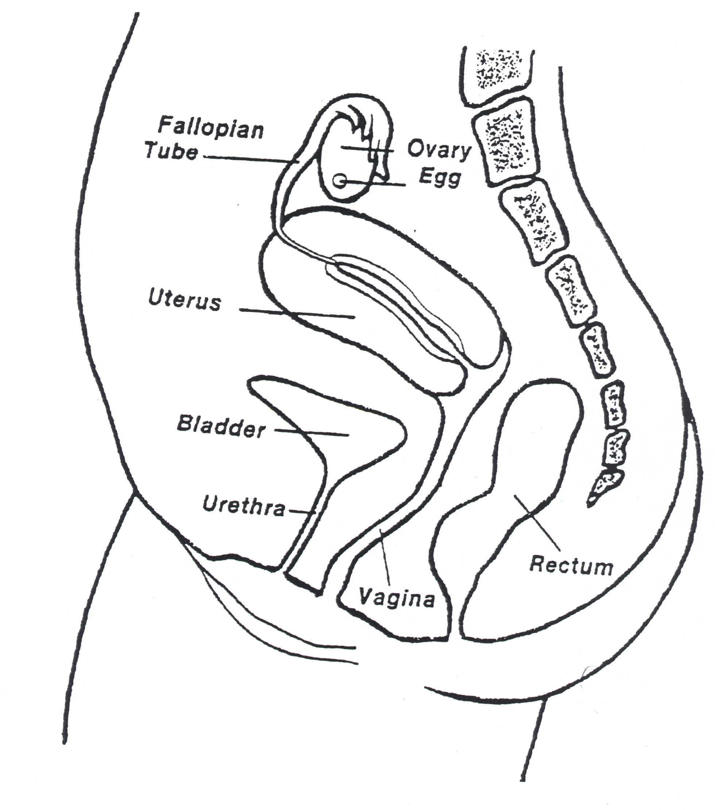

Breasts The part of the chest in a female that begins to grow during adolescence (age approximately 12 or 13, yet differs with each girl). The breasts make and produce milk, and store milk after childbirth. In some cultures a woman’s breasts are considered sexual organs. Girls’ breasts are very sensitive and do activate sexual feelings in the body when touched.

Cervix The lower end of the uterus that joins the uterus to the vagina. During childbirth the cervix opens to approximately four inches to allow for the delivery of a baby.

Vagina The elastic, muscular passageway leading from the cervix to the external sex organs in the female through which menstrual blood passes; also the canal facilitating the birth of a baby.

Uterus A pear-shaped organ inside the woman’s body where the fertilised
egg develops into a full baby (egg from the woman and fertilised by the male sperm).

Ovaries The two primary female sex glands located at either side of the
uterus that produce eggs (ova) and hormones. These female
hormones are estrogen and progesterone.

Fallopian Tubes The tubes leading from the ovaries to the uterus.

Clitoris The small, rounded organ located at the junction of the minor labia. It has no function in reproduction, but is the most sensitive part to sexual stimulation. In some cultures, female circumcision is practiced thinking this will stop the woman from sexual promiscuity (sleeping around). In some cultures only the male or husband is to receive pleasure from the sex act. This is not a Biblical view. Read 1 Corinthians 7: 2-5 where the Bible instructs that both husband and wife are to give themselves to one another sexually for mutual benefit, not just for the husband, but for both the husband and wife, and neither is to deprive the other sexually, except for fasting and prayer.

Hymen A thin membrane that is often found covering the vaginal
opening of a female. In a virgin girl this membrane may remain
attached until marriage where it is broken during the first sexual act. In some cultures, virginity tests are carried out in young girls reaching puberty, to be sure they are not sexually damaged. This test is not always accurate because this membrane can be torn by activities such as riding a bicycle, riding a horse, etc. A girl may also be engaging in dangerous sexual activity without full penetration of the man’s sexual organ. Some girls are born without a hymen. So a virginity test is not always accurate.

Vulva The external genital area where the clitoris and labia, and vaginal
and urethral openings are found.

Ovum The egg, or female reproductive cell that when fertilised, forms a human baby. If not fertilised, the ovum or egg is eliminated from the body during the menstrual cycle of the girl.

Ovulation The process by which a mature egg is released from the ovary in a woman’s body.

Menstruation The shedding off of the lining of the uterus and the female unfertilised egg that occurs at approximately 28 day intervals in a woman’s body, if an egg is not fertilised by a male sperm. If the male sperm does fertilise a female egg, a pregnancy occurs. A girl usually begins monthly menstruation at the onset of puberty or at about age 12 or 13. The time can differ with each girl.

Conception The point at which a male sperm fertilises the ovum or female egg and a new baby life begins. Many pro-abortionists believe that life only begins at birth. The writers of this manual believe that in the context of the Bible, human life begins the moment of conception where God breathes His life into the unborn baby, regardless of the stage of development in the mother’s womb (Genesis 2:7).

Urethral Opening This is a small opening located below the clitoris, where body liquid waste (urine) is discharged from the body. Unlike the male, the female urinary system is not related to the reproductive system.

A Girl’s Body Explained
SEXU 47
A girl growing up, as well as a young boy, needs godly instruction about her gift of sexuality firstly from her parents, the extended family elders, and role models in the church. Girls and boys, are equally valuable in God’s sight, though girls play different roles in the family from boys. The teen years should be a time of character development and practical education so as to prepare her for womanhood, marriage and subsequent motherhood. In some cultures, girls and women are considered ‘property’ of the family and/or subsequent husband. This is not a Biblical view. In terms of the AIDS pandemic this has produced devastating consequences for women and their unborn children. (See next paragraph on Women and AIDS.) In many cultures including Western, the lack of female empowerment has caused women to have little or no say over their body. Pregnancies out of wedlock were blamed on the woman and the care of single parent families has been left largely to women. It is the church’s role to assist communities in teaching girls their personal value, their responsibility in right moral choices over their body, and their rightful place to become productive members of their family and community.
SEXU 08
SEXU 07

Women and HIV/AIDS

In the 1980s and well into the 1990s, men exceeded women in HIV infection. By 1997,
STAT 33
women were becoming infected approximately 33% faster than were men. The effect this has on the unborn children and family system is also taking its toll. The following are some wrong beliefs about women that the church must correct:

- That women should not have empowerment over their body.
This thinking, unfortunately, in some cultures has also included the woman’s sexuality. Many girls and wives are made to believe that their body belongs to the man and they are to give themselves sexually, without any questions asked. This teaching is contrary to Bible teaching where 1 Corinthians 7:4 teaches that both the husband and the wife each have authority over the body of the other, willingly by submission. This is not one-sided. A woman should willingly give herself to her husband sexually, but should not be forced. Young girls must be taught that boys do not have the right to their bodies sexually at any age or time. A young girl must also be taught that it is right to say “NO” to any person who wants to have sex with her, except for her husband.
SEXU 49
SEXU 48
- That women only are responsible for unwanted pregnancies, or pregnancy outside of marriage. Again, the church has a task to teach all members of the community that moral choices are the responsibility of both the girl and the boy, not just the girl. Children born are the responsibility of both the mother and father who conceived them, not just the girl.
SEXU 50
- That men are permitted to have girlfriends outside of the marriage, because they are male. This is contrary to teaching of the Bible that men are instructed by God to have one wife (1 Corinthians 7:2) and he is to love her (Ephesians 5:25) until death takes one of them. A women who suspects her husband has sexual partners (girlfriends) outside of the marriage should be supported as she endeavours to solve these problems. The same would be true for the husband. A wife who has reason to know that her husband is sleeping with another woman, should not feel she must have sexual relations with him and put herself and unborn children at risk for HIV and AIDS. The marital problems should first be resolved and the unfaithful partner be tested and known to be HIV free. Many communities are seeing a greater proportion of women being infected by unfaithful husbands. They are bringing HIV infection to her unknowingly, and wiping out entire families.
SEXU 51
- That only women infect with HIV and men do not. This is not true. Both men and women who are infected with HIV can infect another person.
SEXU 52
- That only women have AIDS, not men. This is not true. Both men and women who contract the HIV virus will eventually get AIDS and will most likely die of AIDS, most within five or so years. It is true, however, that women can be more easily infected with HIV than men. This is due to the
physical make-up of the female’s body. The HIV virus cannot penetrate the skin on the outside of the body (hands, legs, etc). There is another skin inside the body that is very delicate and easily torn and it is called mucosal skin. This skin is found inside one’s mouth…it is soft, delicate and tears easily. This same mucosal skin is found on the male private part (penis) but only a small amount is actually this delicate skin on a male. However, this same mucosal skin is found in greater amounts inside the woman’s body, up in the private parts, which means a woman has more delicate skin that can tear or break, giving entrance to the HIV virus. A woman’s private parts have more entrances for the HIV virus (the urethral opening, the vaginal opening, the anal opening). During sexual intercourse, both the woman and the man can have small breaks in the skin (you won’t see or feel them) caused by the rubbing during intercourse which can allow the HIV virus causing AIDS to enter. However, the woman has much more chance of breaks in the skin because she has more mucosal or delicate skin in her private parts than a man.
SEXU 53

The increasing worldwide infection of women at a much faster rate than HIV infections in men is great cause for concern. The often-held idea that the “girl child” only should be educated about sexual empowerment is one-sided. Both “boy and girl children” should be taught self-worth, self-respect, responsibility, right choices, and respect for others, including the opposite sex. This is taught in the context of the Bible and should be taught in the home of Christian families and by the church.
SEXU 54

What the HIV Virus Does upon Entering a Body
FACT 09
- It primarily targets the immune system.
FACT 33
- It targets T-helper cells (can be compared to army captain cells) and destroys the cell it invades.
- The HIV virus replicates itself every 24 hours making at least 300 million to 2 billion new HIV viruses that cause the host cells to rupture. They destroy that cell and then millions of newly created viruses go and find more helper cells to invade. This cycle goes on and on.
FACT 34
- For some time (can be for a year and up to 10 years or more depending on the infected person’s body) the immune system has sufficient soldier cells to still ward off most sickness and the person remains healthy for a while.
FACT 10
- Then at some point, the body so lacks soldier-fighter cells because so many have been destroyed by the HIV virus, that this infected person begins to have symptoms that do not go away. This is called the ARC (AIDS Related Complex) stage of infection. This can last from months, up to a couple of years.
- Once the HIV-infected person’s body becomes depleted of good soldier-fighting cells in the immune system, he/she contracts a disease which does not go away. It leads to recurrent illness; the body becomes sick and unable to fight the enemy disease, and now the infected person moves into full-blown AIDS.

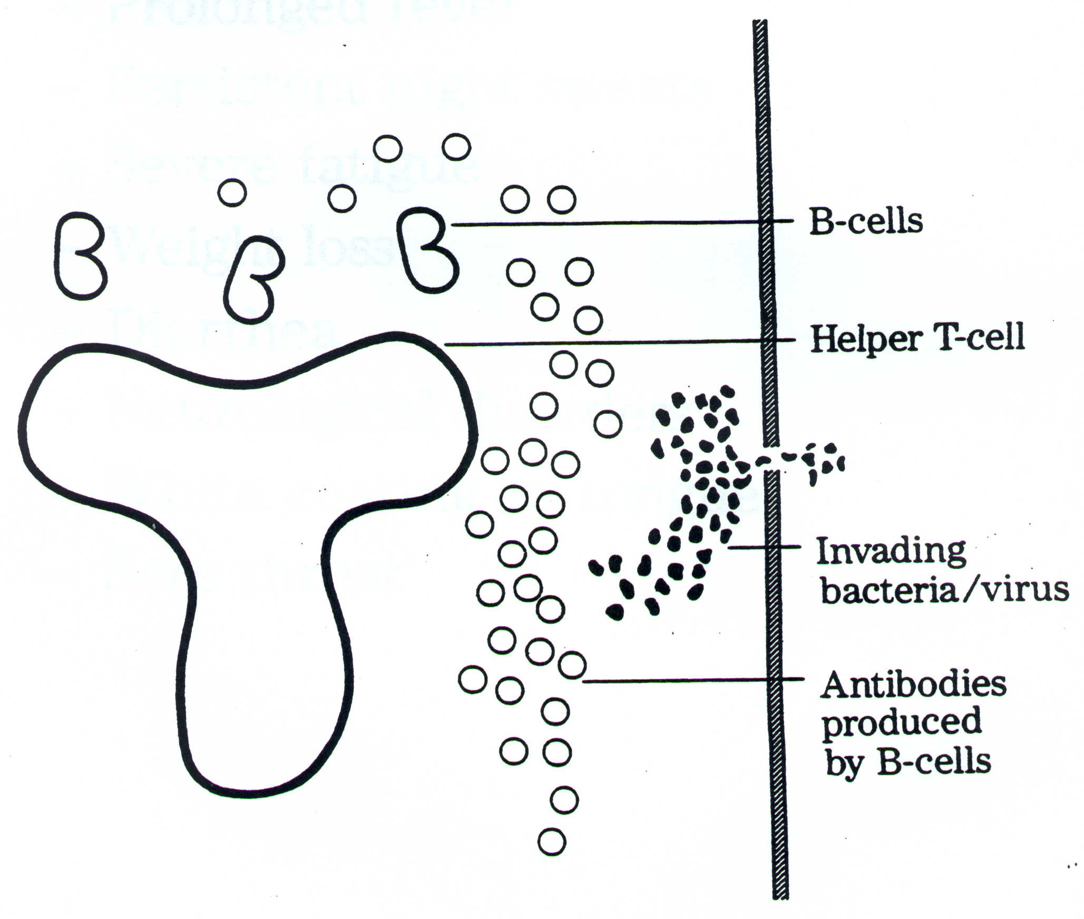

Four Stages of HIV Infection

- Stage One or the HIV-Positive Stage
Where the virus is in an incubation stage, is invading and multiplying in the body’s cells but the person still feels quite normal, looks healthy and generally does not even know that they are infected. Again, this is where HIV infection is deceptive and cheats us. This stage can be as little as 1 to 2 years after initial infection or as long as over 10 years. Most HIV-infected persons in Africa begin to develop symptoms of illness within 3 to 5 years.
FACT 35

- Stage Two or Night Sweats/Swollen Glands
These symptoms can seem very much like the flu so most HIV-infected people at this stage do not even associate these with being HIV+. After 2 or 3 weeks these symptoms completely disappear for the majority of people.

3. Stage Three or the ARC (A-ids R-elated C-omplex) Stage
Where the virus has now invaded and destroyed sufficient T-helper immune cells in the body and the person starts to get symptoms that do not go away. These can be swollen glands in the neck, under the arms and in the groin. Other symptoms can be fever, weight loss, diarrhea, coughing, bleeding in women, flu-like feeling and other persistent symptoms. This stage can last for months or a couple of years.

4. Stage Four or the Full-Blown AIDS Stage
(A-cquired I-mmuno D-eficiency Syndrome) AIDS is the last stage of infection. The virus has now replicated itself billions of times, invading and killing valuable soldier-fighter cells, and the body now cannot defend itself and has a deficient immune system. The body can no longer fight and gives in to all kinds of illnesses and diseases. Once the person reaches this stage he or she may only live for days, weeks or a few months. Usually people with AIDS cannot do much for themselves because their body is in such a weakened state. This is another area where the Christian Church can show the compassion and love of Jesus by getting involved in home-based care instruction and help. They can also dispel the fear of AIDS by demonstrating that visiting and comforting AIDS patients WILL NOT infect you with AIDS. That is a myth; AIDS is not contracted in this casual manner.
FACT 10

Simple Rules for Not Contracting HIV and AIDS
FACT 12
RULE ONE: Use a brand new needle or instrument every time you need to stick your skin, e.g. immunisations, piercing of ears, tattooing, circumcision, etc. If a brand new needle is not available, do not stick your skin unless you boil the needle or tool for 30 minutes before every use. Never take a chance.

Cover cuts and sores with a waterproof plaster. If at the scene of an accident, use surgical gloves or a plastic bag to cover your hands when administering first aid.

RULE TWO: Remember, your sex is a God-given gift to you! Keep your sex until you find that special person God gives you in marriage to share yourself with. If you are married, remain faithful to your spouse only, for sex, until the end of your or your spouse’s life. If you remarry after a spouse’s death, be sure that the person you remarry is tested HIV-negative before your remarriage. If you are single and are getting married, both of you should get an HIV test to be sure that neither one is bringing HIV into the marriage.
FACT 15
SEXU 12
SEXU 09

What Does One Do If Planning Marriage and One Partner Tests HIV Positive?
This calls for much prayerful advice from your elders, Pastor and extended family. An unmarried person could test HIV positive because of the following: he/she was molested or raped; in very rare cases because he/she was born HIV positive from the mother; sexual activity before marriage; and casual infection from an infected needle prick or contaminated tool. Most persons testing HIV positive will have contracted the HIV through sexual contact with an infected person. An HIV-positive person before marriage will have the following decisions to make:

- You can decide not to marry. This would be difficult but may spare you the burden of facing AIDS in your marriage later on. It may also spare a baby being infected or orphaned because there was a resulting pregnancy in the marriage. In this case, if one partner getting married is found to be HIV positive and the marriage does not go through, love and sensitivity should be demonstrated to both the infected and non-infected persons of this situation. This is where the Church can minister to those persons rather than judging and discriminating against them. Rather, lead those hurting people to Jesus.
2. You can decide to marry and have no private-part sexual contact at all. This would the couple decides to go on with their marriage with one person infected, and to express their love in non-sexual forms by hugging, kissing, stroking, etc., but not by sexual intercourse. This couple should be discouraged from having children, especially if it is the wife who is infected. This couple could also have sexual intercourse with the husband using a condom. It is important to note that the condom does have value here, but it is not a 100% safeguard against HIV infection, even if used correctly every time. (Please read Chapter 10 on condoms.)
3. You can decide to marry, have normal unprotected sexual intercourse, and be prepared
to die with your infected spouse. Some people feel strongly that they are prepared to
die for the person they will marry. Couples getting married should carefully make
their choices if they know one or the other partner is infected. The ONLY way one
can know for sure is to have premarital testing. We, the authors, are recommending
in this day of rapid HIV infection and AIDS that the Christian church pastor should
make testing a mandatory part of the pre-marriage planning for couples wanting to
marry in the church. HIV-infected couples choosing to marry anyway, should always
be sure they have the blessing of their extended family before choosing Option #3.

RULE THREE: If you have ever been at risk for HIV infection at any time (even if you are not presently showing symptoms) for any reason (such as molestation, infected blood contact, having sex with a possible infected person, etc.), then GET TESTED before you enter into marriage or have sex.
TEST 20

RULE FOUR: If a woman plans to get pregnant or breastfeed the baby, and there is a possibility you could have been HIV infected, or your sexual partner might possibly be infected, GET TESTED FOR HIV before you become pregnant or breastfeed your baby.
TEST 21

What is the Difference between HIV and AIDS?
HIV is the virus that causes the disease called AIDS. A person first becomes infected with the HIV virus. He/she stays and looks healthy for some time. He/she then begins to have symptoms that do not easily go away. These symptoms are not always the same for every infected person:
FACT 36
- sore throat, fever/s, flu-like feeling
FACT 37
- weight loss
- swelling of the glands, usually felt in the neck and under the arms
- skin rashes, dry and itchy skin
- fungal infections, in nails and/or private parts
- recurrent ulcers in the mouth
- shingles, pneumonia, etc. that does not seem to go away.

Therefore, HIV infection moving to full-blown AIDS is not just one disease; it can come in many forms (TB, pneumonia, coughing, flu, etc.). AIDS is any sick condition in the person where the body cannot fight and chase it away due to the immune system being deficient from the HIV virus’ invasion. HIV and AIDS in most cases is a preventable disease and it is BEHAVIOUR that puts a person at risk.
FACT 22

Why Is a Cure for HIV and AIDS So Difficult?

This is because the HIV virus in the body becomes part of the infected person’s DNA genetics. We illustrate this simply by saying that once in the cell, the HIV virus mixes with the inherited genetic factors of DNA (such as hair, eye, skin colour) and mixes like soap and water in a washing machine. It is scientifically beyond us, at the time of writing this curriculum, that a medical cure will soon be found to remove the HIV virus in a body, once it has mixed into the genetic DNA. Neither a pill, medicine, muti or mixture can effectively alter DNA, nor can it cure a body that is HIV infected. There is no effective immunisation (shot) or cure for HIV infection resulting in AIDS at any stage of infection, as we write. The only exception is Divine healing from Almighty God that can cure an HIV-positive person or one with AIDS.
FACT 38

